Software Requirements Specification
for

Online Store for Medical Equipment
Version 1.0 approved

Prepared by:
Mohamed Ahmed Arafa: 320240185 Moatassem Muhammed : 320240182 Ziad Ahmed Ezzat : 320240183 Jamal Hany Jamal : 320240181 Ahmed Samir Saad : 320240180 Ahmed Bassem Refaat : 320240184
<20/11/2025>

Copyright © 1999 by Karl E. Wiegers. Permission is granted to use, modify, and distribute this document.

Table of Contents
Introduction 1
Purpose— 1
Document Conventions— 1
Intended Audience and Reading Suggestions 1
Product Scope— 1
References— 2
Overall Description 2
Product Perspective — 2
Product Functions— 3
User Classes and Characteristics— 4
Operating Environment— 5
Design and Implementation Constraints— 5
User Documentation— 5
Assumptions and Dependencies— 6
External Interface Requirements 6
User Interfaces— 6
Hardware Interfaces— 6
Software Interfaces— 6
Communications Interfaces— 7
System Features 7
Product Browsing & Search— 7
Product Details View— 8
Shopping Cart & Ordering — 8
User Account Management — 9
Other Nonfunctionl Functions
Performance Requirements 11
Safety Requirements 11
Security Requirements 12
Software Quality Attribute 12
Business Plan 12
Diagrams
6.1 Use Case-----------------------------------------------------------------------------------------------------------13
6.2 Narrative Use Case-----------------------------------------------------------------------------------------------14
6.3 ERD-----------------------------------------------------------------------------------------------------------------25
6.4 SQ-------------------------------------------------------------------------------------------------------------------26
6.5 DFD-----------------------------------------------------------------------------------------------------------------27
Revision History

Name | Date | Reason For Changes | Version

Software Requirements Specification for Online Store for Medical Equipment Page 1

Introduction

Purpose
The purpose of the Medical Supplies Application is to provide a unified digital platform where users can easily browse, purchase, and manage medical supplies and equipment. The application focuses exclusively on offering a convenient and reliable online shopping experience for medical products. It aims to enhance accessibility to essential medical equipment, streamline the purchasing process, and ensure users can find the products they need quickly and efficiently. By centralizing a wide range of medical supplies in one system, the application supports improved convenience, faster ordering, and seamless management of medical equipment purchases.

Document Conventions

Bold text is used for section titles and important terms.
Italic text may be used for emphasis or definitions.
Numbered headings follow the standard IEEE SRS structure (1.x, 2.x, 3.x).
Technical terms are used consistently throughout the document.

Intended Audience and Reading Suggestions
This document is intended for:

Developers, who will use the SRS to understand system requirements and design the architecture.
Project Managers, who will reference the SRS for planning, tracking, and evaluation.
Clients and Stakeholders, including healthcare providers and administrators, who require an overview of system capabilities.
Testers, who will use the requirements to design and execute test cases

Product Scope
The Medical Supplies Application provides an integrated platform that connects users with essential healthcare resources. The scope of the system includes:
Software Requirements Specification for Online Store for Medical Equipment Page 2

Browsing and ordering medical supplies.
Viewing medical product details and availability.
Secure user authentication and profile management.
Allowing administrators to manage inventory and system data.
The goal is to enhance accessibility, convenience, and efficiency within the healthcare service ecosystem

References
The following references were used in preparing this SRS document:
IEEE Standard 830-1998: Recommended Practice for Software Requirements Specifications.
Course-provided SRS templates and guidelines.
General medical supply system documentation and healthcare appointment system references.
Geeks for geeks

Overall Description

Product Perspective
The medical supplies and equipment web platform is a new , online system designed to provide clinics, hospitals, pharmacies and even normal individuals in Egypt with access to a wide range of medical supplies and equipment and products from all over the world.
Software Requirements Specification for Online Store for Medical Equipment Page 3
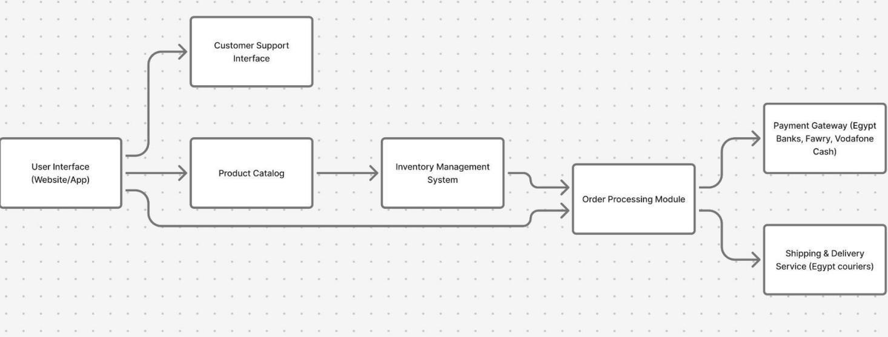

Product Functions
Display products: Show medical consumables and equipment such as masks, gloves, devices, tools and more.

Search & filtering: Allow users to search for products by category, brand, supplier, price and country.

Product details page:Display product specifications, images, pricing, availability and ratings.

Add to cart /order: Allow users to submit purchase requests and save it in a shopping cart for later.

User Account Management: Allow customers to register and manage their profiles and update it.

Customer support & contact: Provide channels and ways for customer inquiries,follow-up and after sales support

Choosing language: Allow the user to choose language wanted based on his preference.
Software Requirements Specification for Online Store for Medical Equipment Page 4

User Classes and Characteristics
The system will be used by the following user classes:
Healthcare Professionals (Doctors, Nurses, Clinics)
Frequent users.

Require accurate product specifications.

Often search for specialized medical equipment.

Moderate technical skill level.

Pharmacy Owners and Distributors
Medium to high usage frequency.

Focus on medical consumables and bulk purchasing.

Need reliable supplier information and price comparisons.

Hospital Procurement Departments
Advanced users.

Look for verified suppliers and large equipment.

Require detailed quotations and strong product filtering options.

General Public (Consumers in Egypt)
Occasional users.
Software Requirements Specification for Online Store for Medical Equipment Page 5

Primarily interested in basic medical supplies (masks, glucometers, thermometers).

May require a simpler and more user-friendly interface.

Website Administrator
Manages products, suppliers, and customer accounts.

High technical authority and access level.

Ensures data accuracy and system security.

Operating Environment

add support to all common web browsers
establishing linux server to host the website
setting database for the products on the site
supporting different device sizes and aspect ratios

Design and Implementation Constraints

the need for separate developers for each of the DB, the front-end framework and server
admins
restriction due to licensing and government paperwork
securing the information and details of every customer,merchant and payment operation

User Documentation

”help me and FAQ page ” to assist the user if he encounters any problem
a tour(or tutorial) after registration for the first time to get the user familiar with the website
Software Requirements Specification for Online Store for Medical Equipment Page 6

Assumptions and Dependencies

the suppliers are providing real information about the products
user can’t buy some products without official prescription from a doctor
third party payment methods
shipping services

External Interface Requirements

User Interfaces
This describes what the users sill see and interact with in the website What it includes:
Home page
medical devices listing page
medical device details page
Shopping cart
Login and registration pages
Checkout page
Admin page(add-delete-edit devices)

Hardware Interfaces
This describes the physical devices needed to run and address the project
Device(laptop-pc-phone)
At least 4GB ram
Any modern CPU
The system should be viewable on any device that can run a modern browser

Software Interfaces
This describes the software platforms the project will use or interact with.
Web browser(Chrome-Firefox-etc.)
Backend server(node.js-PHP-python)
Database(MySQL-Firebase)
Software Requirements Specification for Online Store for Medical Equipment Page 7

Communications Interfaces
This describes how the system exchanges data over the network
Browser& Web server communication
Server& Database communication

Summary:
The system includes user interfaces users interact with, login, view medical products, cart, and simple checkout. It also includes hardware devices used like pcs or laptops. Furthermore, software interface like a modern browser, local server, database. Finally, communication interface that represents how the system communicates and how data is exchanged like (HTTP-HTTPS, GET/POST requests).

System Features

Product Browsing & Search
Description and Priority
Users can view medical products, search, and filter items.
Priority: High

Stimulus/Response Sequences
User opens the Products page → System loads product list.
User enters a search keyword → System shows matching products.
User applies filters (category, supplier, price, etc.) → System updates the list.

Functional Requirements
REQ-1: The system shall display all available products with images, name, and price.
Software Requirements Specification for Online Store for Medical Equipment Page 8

REQ-2: The system shall allow users to search products by keywords.
REQ-3: The system shall allow filtering by category, brand, supplier, and price.
REQ-4: The system shall return “No products found” when no item matches the search.
REQ-5: The system shall load products within 3 seconds under normal conditions.

Product Details View:
Description and Priority
Users can view detailed info about a selected medical product.
Priority: High

Stimulus/Response Sequences
User clicks a product → System opens the product details page.
User scrolls images or details → System shows full information.

Functional Requirements
REQ-6: The system shall show product description, specifications, price, stock, and supplier.
REQ-7: The system shall allow showing multiple product images.
REQ-8: The system shall notify the user if the product is out of stock.
REQ-9: The system shall prevent users from buying prescription-required items without submitting a doctor’s prescription (TBD process).

Shopping Cart & Ordering

Description and Priority
Users can add items to a cart and proceed to checkout.
Priority: High

Stimulus/Response Sequences
User clicks “Add to Cart” → System adds product to the cart.
User opens the cart → System shows items and totals.
User proceeds to checkout → System redirects to payment page.

Functional Requirements
Software Requirements Specification for Online Store for Medical Equipment Page 9

REQ-10: The system shall allow adding and removing items from the cart.
REQ-11: The system shall update total cost automatically.
REQ-12: The system shall not allow checkout with an empty cart.
REQ-13: The system shall handle payment through third-party methods.
REQ-14: The system shall show an error if payment fails.

User Account Management

Description and Priority
Users can register, log in, and manage personal profiles.
Priority: High

Stimulus/Response Sequences
User clicks “Register” → System shows sign-up form.
User logs in → System validates credentials and opens dashboard.
User edits profile → System saves changes.

Functional Requirements
REQ-15: The system shall allow users to create an account with email and password.
REQ-16: The system shall authenticate users securely.
REQ-17: The system shall allow users to update their profile info.
REQ-18: The system shall reset passwords through email verification.
REQ-19: The system shall display errors for invalid login attempts.

Other Nonfunctional Requirements

Performance Requirements:

The system should load all main pages within 2–3 seconds under normal network conditions.
Search results should appear within 1 second for typical product queries.
The system should support at least 200 concurrent users without slowing down.
The database should respond to requests (read/write) within 1 second on average.
The system should process checkout and payment actions within 3 seconds.

Safety Requirements
The system must prevent users from purchasing medical items that legally require a prescription unless a valid prescription is provided.
The system must clearly warn users about medical products that have usage risks or require professional handling.
The system must prevent any action that could lead to incorrect orders, such as submitting an empty cart or duplicating payments.
Software Requirements Specification for Online Store for Medical Equipment Page 10

The system must validate all data inputs to prevent harmful system behavior (e.g., crashes or corrupted records).
The system must comply with any local regulations related to the sale of medical equipment in Egypt.

Security Requirements
The system must protect all user data using secure encryption during storage and transmission.
Users must authenticate through a valid email and password before accessing personal or sensitive information.
Admin-level features must be restricted through role-based access control.
The system must block accounts temporarily after multiple failed login attempts.
All communication between the user and server must use HTTPS.
Sensitive actions (login, payments, account edits, product modifications) must be logged for security auditing purposes.

Software Quality Attributes
Usability: The system should be easy to navigate, with clear layouts, simple menus, and consistent design across all pages.
Reliability: The system should operate without crashes and maintain at least 99% uptime.
Maintainability: Code and components should be organized so developers can update or fix features with minimal effort.
Portability: The system should run smoothly on major browsers (Chrome, Firefox, Edge) and across desktop and mobile devices.
Scalability: The system should be able to handle increased product listings and higher numbers of users without performance drops.
Availability: All main features (search, product viewing, checkout) should remain accessible during normal operating hours.
Testability: Features should be structured in a way that allows easy creation of test cases for both frontend and backend.

Business Rules
Only registered users can place orders or access their purchase history.
Admins are the only ones allowed to add, edit, or remove medical products from the system.
Products that require a medical prescription cannot be ordered unless a valid prescription is uploaded.
Prices and availability shown to users must match the data provided by suppliers.
Discounts, promotions, and offers must follow the rules set by the business (e.g., expiry dates, usage limits).
Payment must be completed before an order is processed for shipping.

Use Case
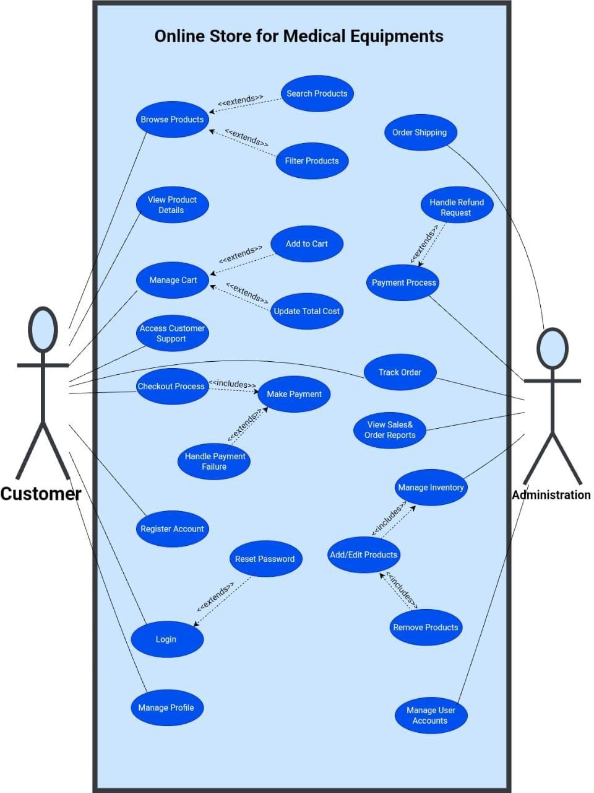

Narrative Use Case
1. Browse Products
Actor: Customer
Description: Customer views a list of available products in the store.
Preconditions: The store is accessible, and products exist in the catalog.
Main Flow:
Customer opens the store.
System displays available products.
Customer scrolls through the list.
Customer selects a product.
Alternative Flow:
Search Products: Customer enters a search query, and the system displays results.
Filter Products: Customer applies filters, and the system updates the product list.
Postconditions: Customer can view product details or continue browsing.

2. Search Products
Actor: Customer
Description: Customer searches for products using keywords.
Preconditions: The store is open and accessible.
Main Flow:
Customer enters a search query.
System searches the database.
System returns matching results.
Alternative Flow:
No Results: System displays a "No results found" message.
Postconditions: Customer views search results or refines the search.

3. Filter Products
Actor: Customer
Description: Customer narrows down the product list using filter criteria.
Preconditions: A list of products is displayed.
Main Flow:
Customer selects filter criteria.
System applies filters.
System displays updated results.
Alternative Flow:
Invalid Filter: System shows a warning message.
Postconditions: Customer views a filtered list of products.

4. View Product Details
Actor: Customer
Description: Customer views detailed information about a specific product.
Preconditions: Customer has selected a product from the list.
Main Flow:
Customer selects a product.
System displays product information.
Customer reviews details.
Alternative Flow: None
Postconditions: Customer can add the product to the cart or return to browsing.

5. Add to Cart
Actor: Customer
Description: Customer adds a selected product to the shopping cart.
Preconditions: Customer is viewing product details, and the product is in stock.
Main Flow:
Customer clicks “Add to Cart”.
System adds the product to the cart.
System updates cart count.
Alternative Flow:
Out of Stock: System displays an error message.
Postconditions: The product is added to the cart, and the cart total is updated.

6. Manage Cart
Actor: Customer
Description: Customer views and modifies items in the shopping cart.
Preconditions: Customer has items in the cart or the cart is empty but accessible.
Main Flow:
Customer opens the cart.
System displays cart items.
Customer updates quantities or removes products.
System recalculates totals.
Alternative Flow:
Update Total Cost: Triggered automatically when changes are made.
Postconditions: Cart contents and totals are updated.

7. Access Customer Support
Actor: Customer
Description: Customer contacts support for assistance.
Preconditions: Support page is accessible.
Main Flow:
Customer opens the support page.
System shows support options.
Customer submits a question.
Support responds or logs a ticket.
Alternative Flow: None
Postconditions: Customer's query is logged, and support follow-up is initiated.

8. Checkout Process
Actor: Customer
Description: Customer proceeds to finalize the purchase.
Preconditions: Customer has items in the cart.
Main Flow:
Customer clicks “Checkout”.
System requests address and shipping information.
Customer confirms details.
System proceeds to payment.
Alternative Flow:
Missing Info: System requests corrections before proceeding.
Postconditions: Customer proceeds to payment or corrects information.

9. Make Payment
Actor: Customer
Description: Customer provides payment details to complete the purchase.
Preconditions: Customer has confirmed shipping details during checkout.
Main Flow:
Customer selects a payment method.
Customer enters payment details.
System processes the payment.
Order is confirmed.
Alternative Flow:
Handle Payment Failure: Invoked if payment processing fails.
Postconditions: Payment is processed, and order confirmation is provided.

10. Payment Process
Actor: Customer, Payment Gateway
Description: System communicates with the payment gateway to validate and process payment.
Preconditions: Payment details have been entered by the customer.
Main Flow:
System sends a payment request to the payment gateway.
Gateway validates the payment.
System confirms payment success.
Alternative Flow:
Declined Payment: System displays an error message.
Postconditions: Payment is either approved or declined.

11. Handle Payment Failure
Actor: Customer
Description: Customer handles a failed payment attempt.
Preconditions: Payment process has failed.
Main Flow:
Payment fails.
System shows a failure message.
Customer retries or chooses another payment method.
Alternative Flow: None
Postconditions: Customer can retry payment or cancel the order.

12. Track Order
Actor: Customer
Description: Customer checks the status of their order.
Preconditions: Customer has placed an order and is logged in.
Main Flow:
Customer opens order tracking.
System displays current order status.
Customer views shipping updates.
Alternative Flow: None
Postconditions: Customer views the latest order status.

13. Order Shipping
Actor: Administration
Description: Admin prepares and updates the shipping status of an order.
Preconditions: Order has been paid and is ready for shipping.
Main Flow:
Admin prepares the order for shipping.
Admin updates the shipping status.
System notifies the customer.
Alternative Flow: None
Postconditions: Order status is updated, and the customer is notified.

14. Handle Refund Request
Actor: Customer, Admin
Description: Customer submits a refund request, which is reviewed and processed by the admin.
Preconditions: Customer has placed an order and is logged in.
Main Flow:
Customer submits a refund request.
Admin reviews the request.
Admin approves or rejects the request.
System notifies the customer of the decision.
Alternative Flow:
Refund Approved: System processes the refund.
Refund Rejected: System explains the reason for rejection.
Postconditions: Refund request is resolved, and the customer is notified.

15. Register Account
Actor: Customer
Description: Customer creates a new account.
Preconditions: Customer is not logged in.
Main Flow:
Customer selects “Register”.
Customer enters required details.
System validates the information.
Account is created.
Alternative Flow: None
Postconditions: Customer account is created, and the customer can log in.

16. Login
Actor: Customer
Description: Customer logs into their account.
Preconditions: Customer has a registered account.
Main Flow:
Customer enters credentials.
System verifies credentials.
Customer is logged in.
Alternative Flow:
Reset Password: Invoked if the customer enters incorrect credentials.
Postconditions: Customer is authenticated and granted access to their account.

17. Reset Password
Actor: Customer
Description: Customer resets a forgotten password.
Preconditions: Customer has a registered account with a valid email.
Main Flow:
Customer requests a password reset.
System asks for the registered email.
Customer enters email.
System sends a reset link.
Customer sets a new password.
Alternative Flow: None
Postconditions: Customer's password is updated, and they can log in.

18. Manage Profile
Actor: Customer
Description: Customer updates their personal information.
Preconditions: Customer is logged in.
Main Flow:
Customer opens profile settings.
Customer updates information.
System saves changes.
Alternative Flow: None
Postconditions: Customer's profile information is updated.

19. View Sales & Order Reports
Actor: Administration
Description: Admin views sales and order data for analysis.
Preconditions: Admin is logged in and has report access.
Main Flow:
Admin opens the reports section.
System displays sales and order data.
Admin analyzes results.
Alternative Flow: None
Postconditions: Admin has accessed the requested reports.

20. Manage Inventory
Actor: Administration
Description: Admin updates product stock and availability.
Preconditions: Admin is logged in and has inventory management access.
Main Flow:
Admin views the inventory list.
Admin updates stock or availability.
System saves changes.
Alternative Flow:
Add/Edit Products: Invoked to add or modify product details.
Remove Products: Invoked to delete products from inventory.
Postconditions: Inventory data is updated.

21. Add/Edit Products
Actor: Administration
Description: Admin adds new products or edits existing product information.
Preconditions: Admin is logged in and has product management access.
Main Flow:
Admin selects add or edit option.
Admin enters/updates product information.
System saves changes.
Alternative Flow: None
Postconditions: Product catalog is updated.

22. Remove Products
Actor: Administration
Description: Admin removes products from the store catalog.
Preconditions: Admin is logged in and has product management access.
Main Flow:
Admin selects a product to remove.
Admin confirms removal.
System deletes the product from the store.
Alternative Flow: None
Postconditions: Product is removed from the catalog.

23. Manage User Accounts
Actor: Administration
Description: Admin views and edits customer account details.
Preconditions: Admin is logged in and has user management access.
Main Flow:
Admin opens the user account list.
Admin views or edits account details.
System updates the account.
Alternative Flow: None
Postconditions: User account information is updated.

Entity Relational Diagram (ERD)

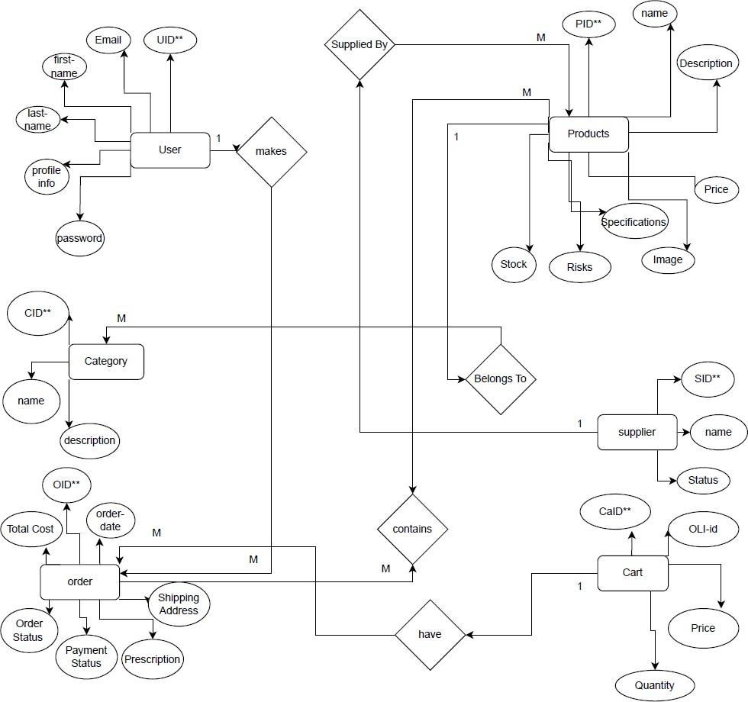
Sequence Diagram
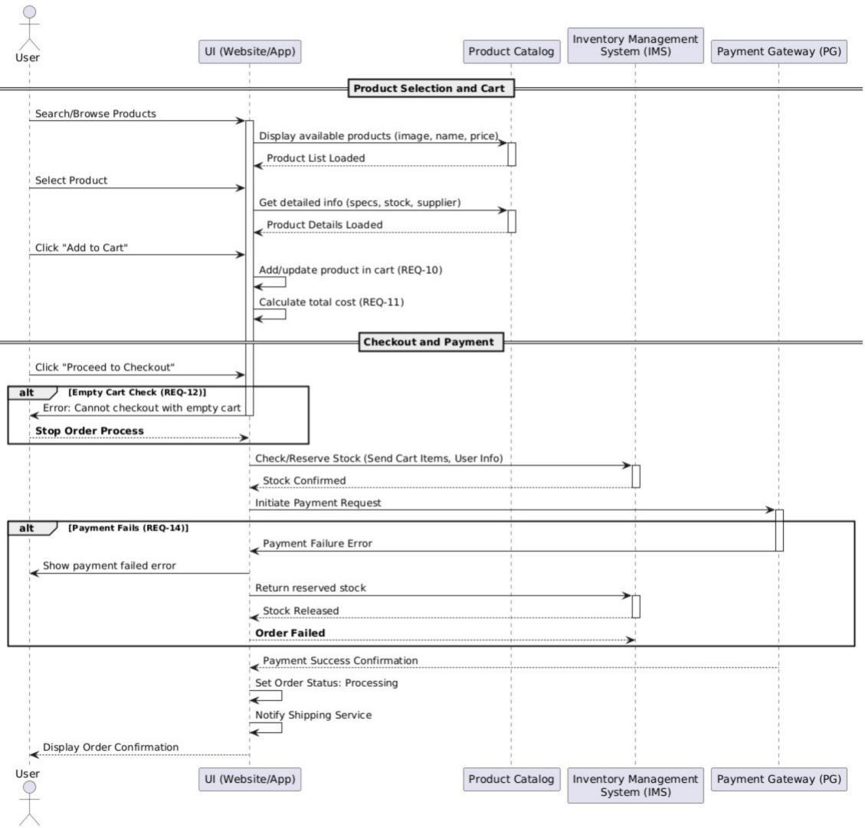

Data Flow Diagram (DFD)
Level 0:
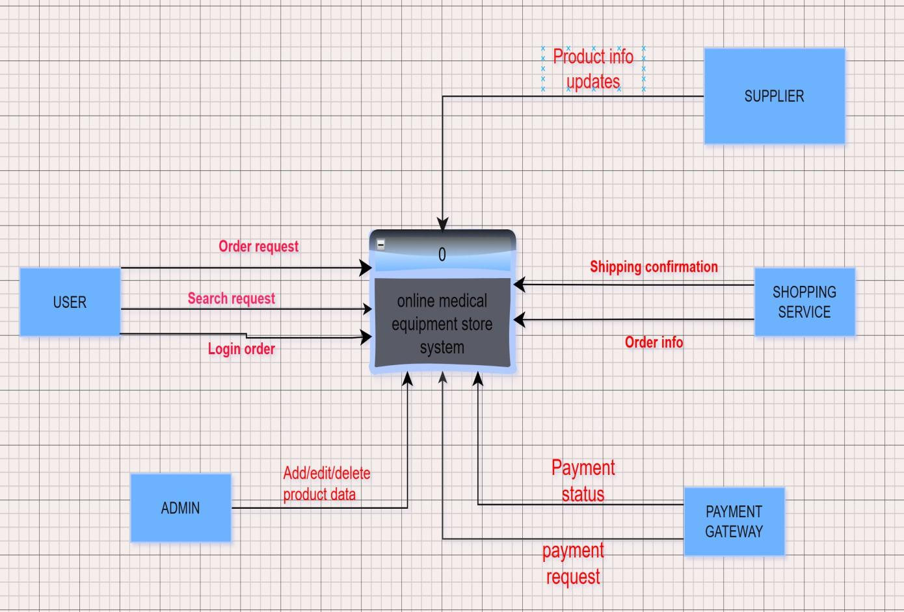
Level 1:
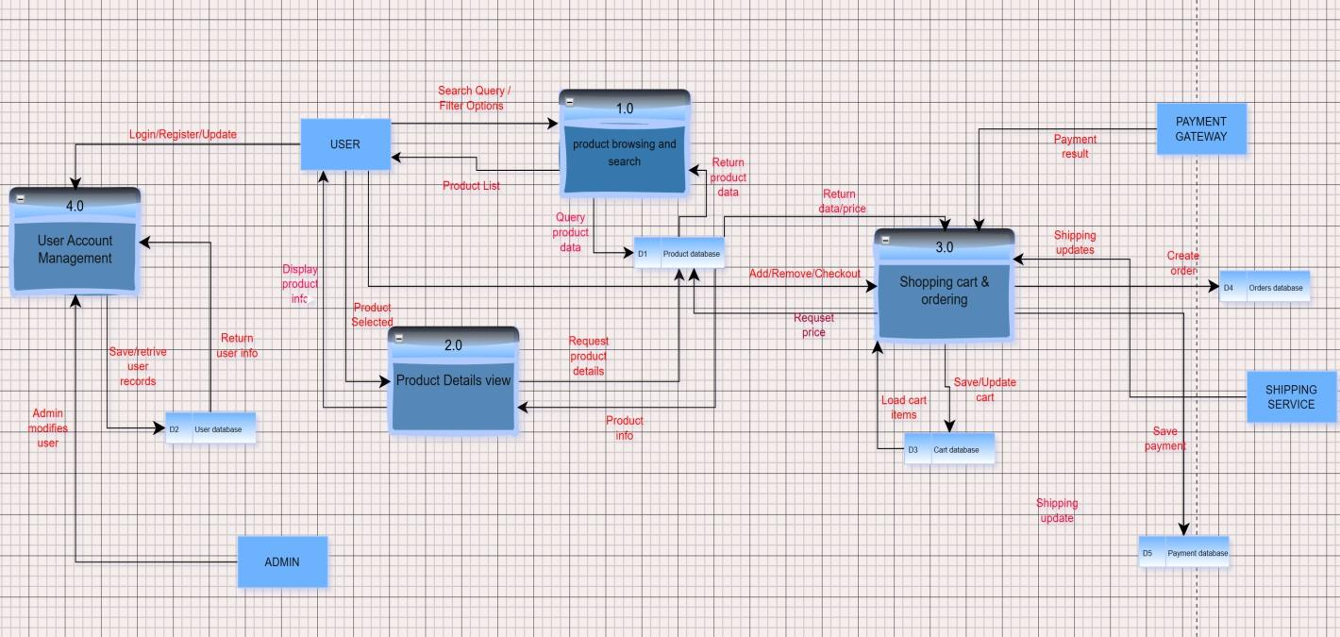

Level 2:
